Ex no: 5 Register no: 220701172

CAPTURING AND ANALYSING PACKETS

USING WIRESHARK TOOL

1.Capturing packets:

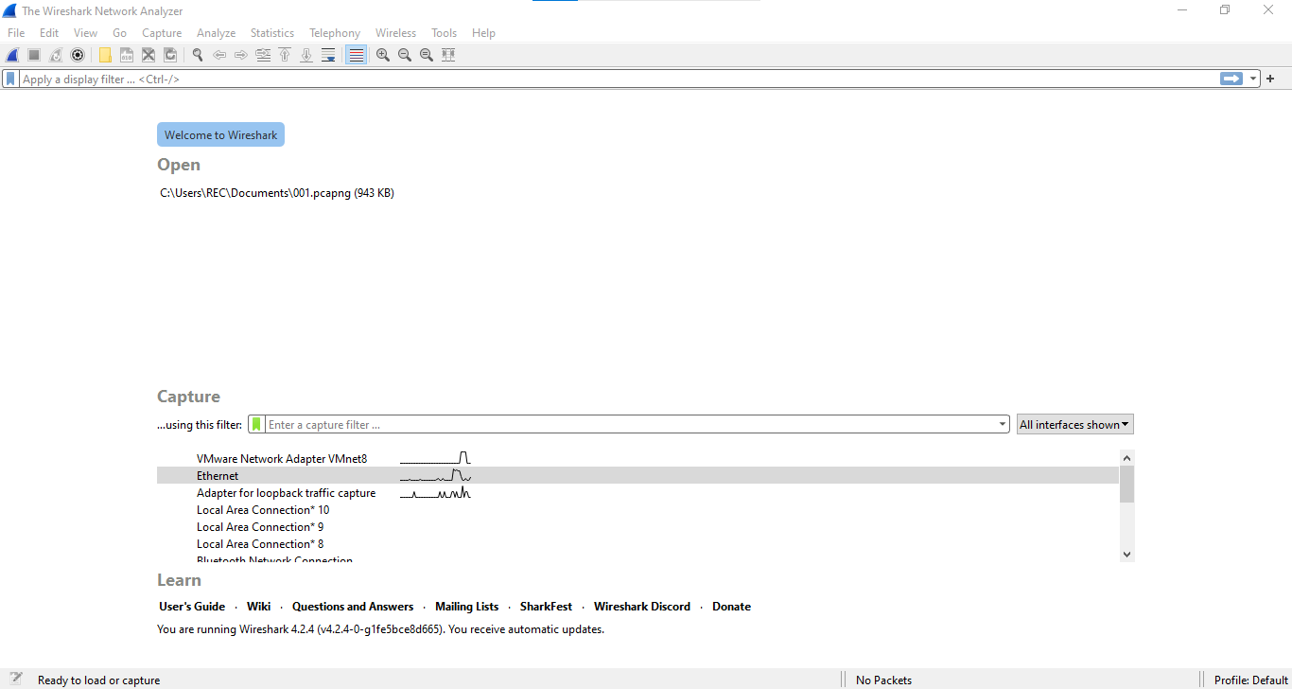

2.Packet list, Packet details, Packet bytes:

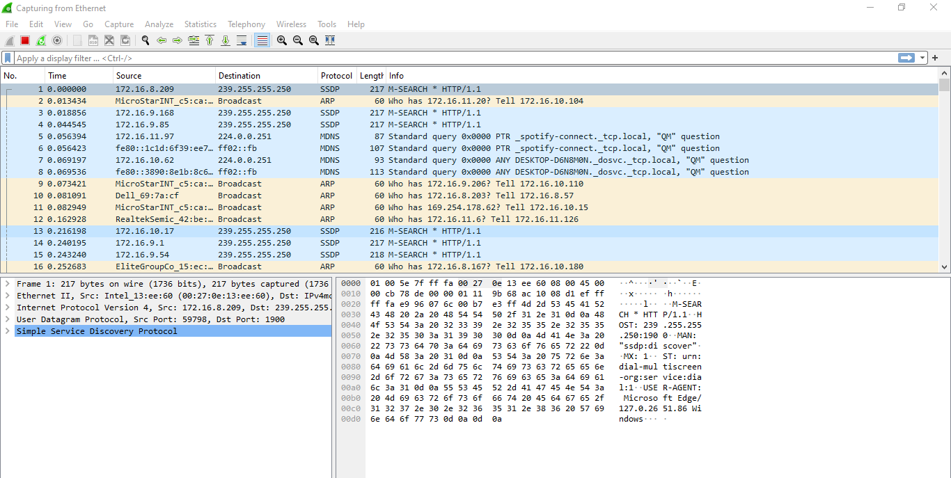

**Packet bytes**

**Packet details**

**Packet list**

3.Color coding:

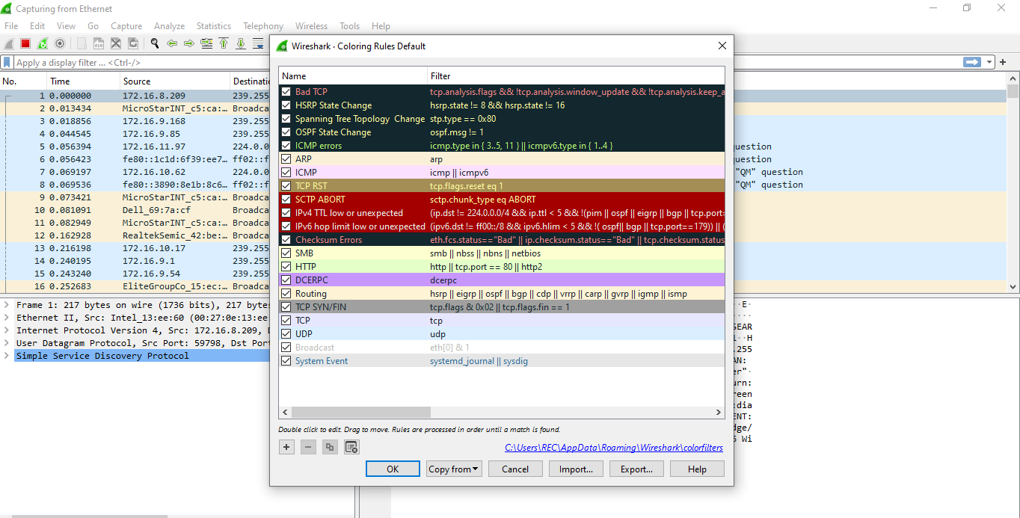

4.Filtering Packets:

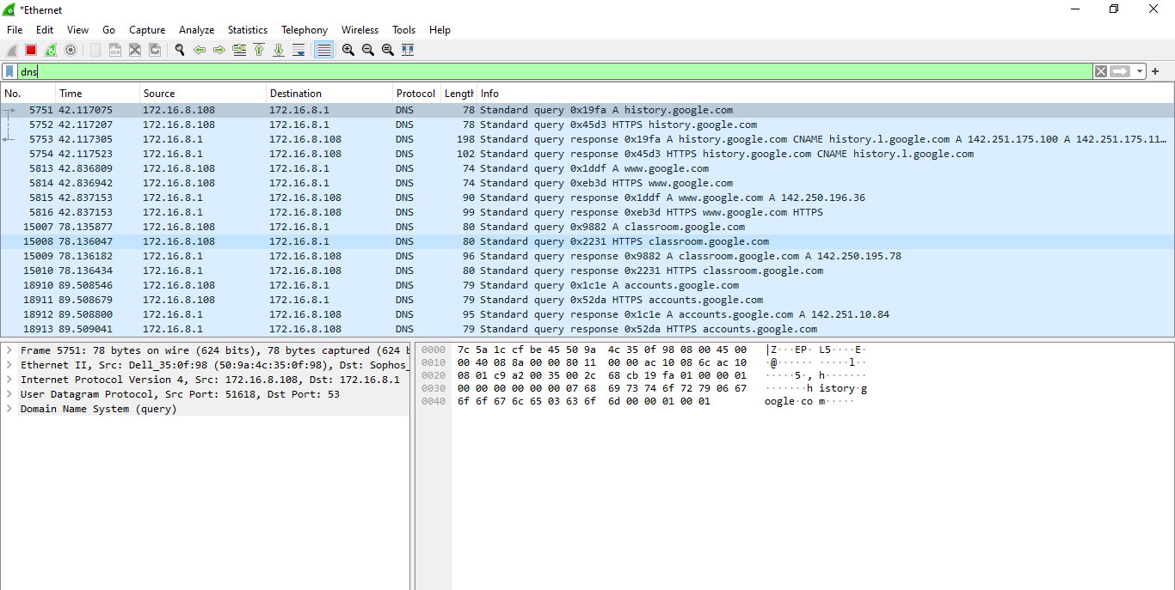

5.Display Filters:

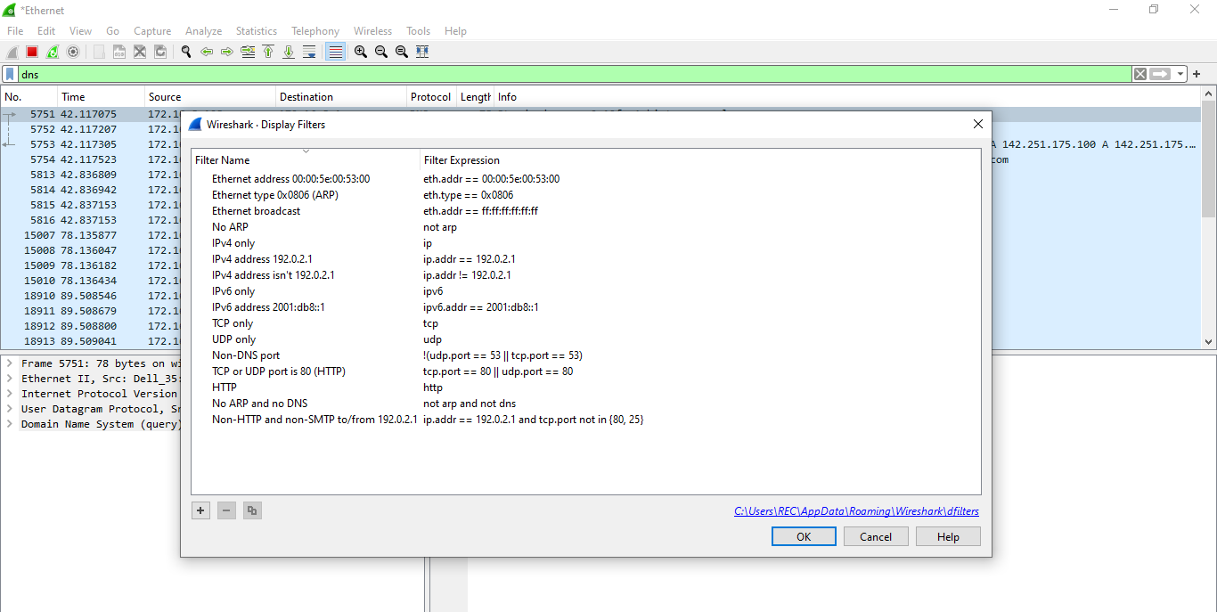

6.TCP Stream:

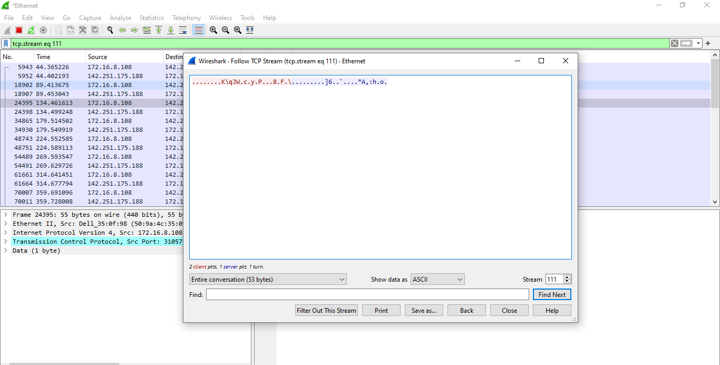

7.Inspecting package:

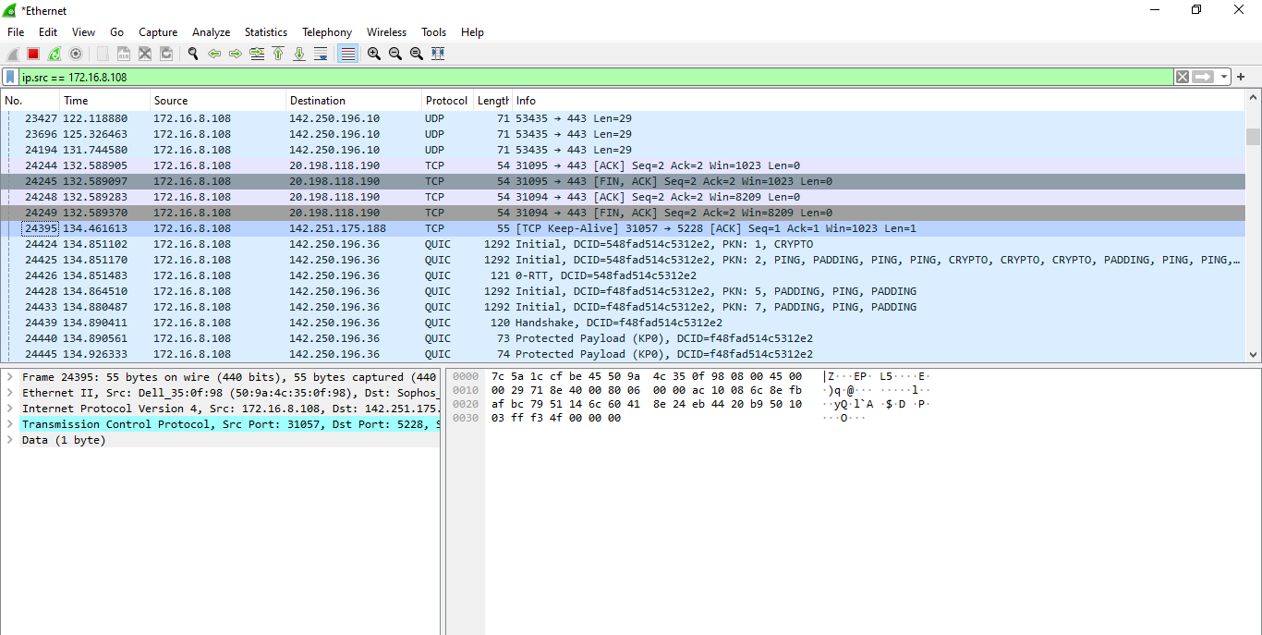

8.Flow Graph:

